Title: Social media app
objective: A social app database service focuses on the building and verifying of online social networks for communities of people who share interests and activities, or who are interested in exploring the interests and activities of others, and which necessitates the use of software. Most services are primarily web based and provide a collection of various ways for users to interact, such as messaging, queries, Advices and file uploading.
Existing Database: innoDB Mysql
OVERVIEW:
This application database is developed to be implemented implemented as a follow up system for current existing system. This system would automate the operations of the social networking and would retain the present functionality available in the current system. The specific purpose of this system is to gather and process information about different projects. And get the status from corresponding users in the community.
Features:
- user: User tables contains his personal data in that table.
- Profile: In this table it is used to update his/her public details to show to all.
- Posts: This application will provide to upload the post they are you following the the user.
- Post likes: this Table contains the who are makes the liks to perticular posts uploaded by the end usert. It will helps to show to the uploades user
- Post comments: This table contains commnets made by the pertion in the followers list and commnet ed on the perticular post
- Invite the friends: users send the invitation request to his/her friends. After login the corresponding user he will see the invitation request and two text boxes (Yes, No).If user clicks on the “Yes" then that user is added into community else otherwise that user is just ignored.
- Messages: passing the messages through sender to receiver through the encrypted form

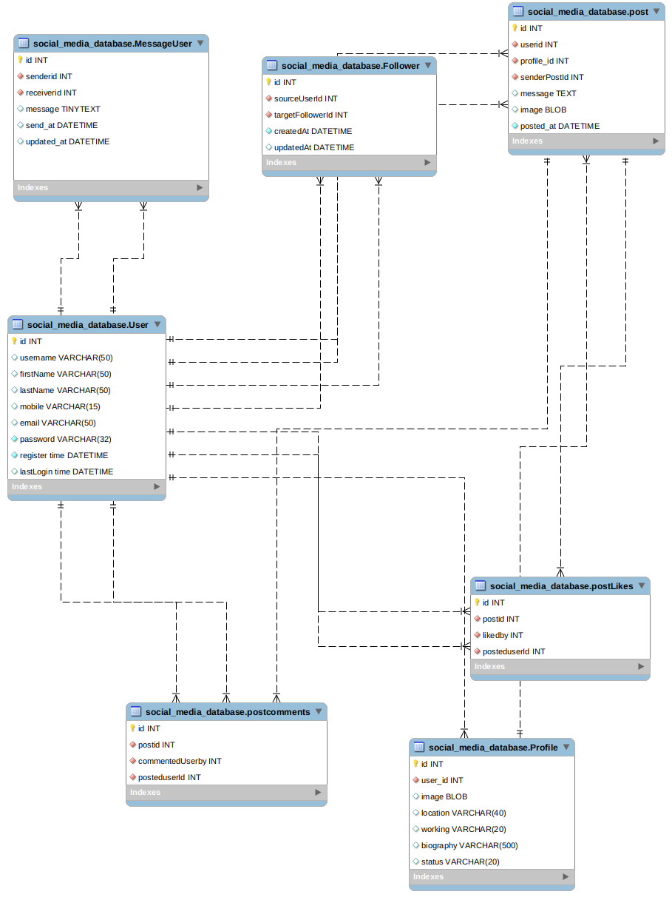
SCHEMA:

